**Assignment 03: Time-Series Data**

The following report presents the application of Recurrent Neural Networks (RNNs) to time-series data, specifically focusing on weather forecasting problems. The assignment aims to explore various methods to improve the performance of RNN models in forecasting weather patterns. The methods include adjusting the architecture of the RNN model, experimenting with different types of recurrent layers (e.g., LSTM, GRU), and incorporating 1D convolutions alongside RNN layers. The report outlines the implementation of these methods, evaluates their performance on validation datasets, and presents the best-performing models tested on the test set. Overall, the report aims to showcase the effectiveness of RNNs in handling time-series data and highlight strategies for improving their forecasting accuracy.

**Summary of the models for time-series data**

|  |  |  |  |  |
| --- | --- | --- | --- | --- |
| **Model** | Dense Units | Dropout | Loss | Test MAE |
| Basic Machine Learning model | 16 | No | 11.6759 | 8.77 |
| Basic Machine Learning model | 64 | No | 11.8205 | 14.13 |
| 1D Convolution model | 16 | No | 15.2386 | 12.73 |
| **RNN models** | | | | |
| Simple RNN | 16 | No | 151.3941 | 9.94 |
| Stacked Simple RNN Model | 16 | No | 151.1465 | 9.91 |
| **GRU** | | | | |
| Simple GRU (Gated Recurrent Unit) | 16 | No | 9.8051 | 2.52 |
| **LSTM(Long Short-Term Memory)** | | | | |
| LSTM-Simple | 16 | No | 10.5209 | 2.65 |
| LSTM - dropout Regularization | 16 | Yes | 11.063 | 2.62 |
| LSTM - Stacked setup with 16 units | 16 | No | 11.0013 | 2.61 |
| LSTM - Stacked setup with 32 units | 32 | No | 11.388 | 2.67 |
| LSTM - Stacked setup with 8 units | 8 | No | 10.2133 | 2.58 |
| LSTM - dropout-regularized, stacked model | 8 | Yes | 11.1213 | 2.58 |
| Bidirectional LSTM | 16 | No | 10.8084 | 2.56 |
| **Combinations** | | | | |
| 1D Convnets and LSTM together | 16 | No | 23.255 | 3.83 |

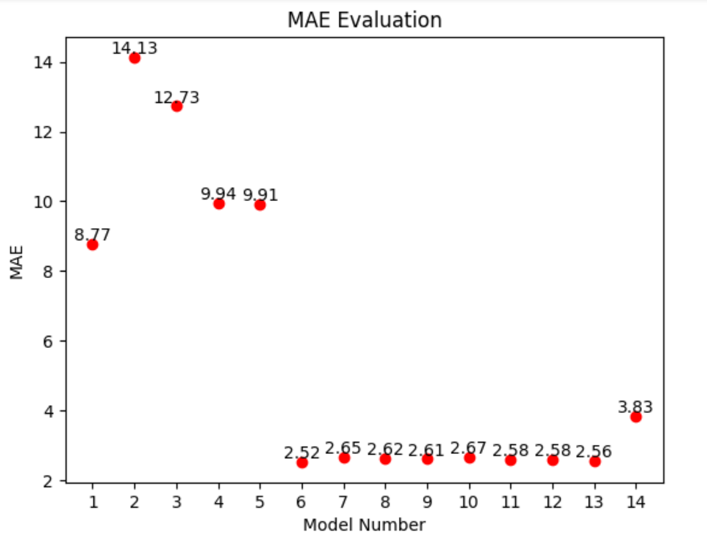**Applying RNNs to Time-Series Data**

* From the results, it's evident that simple RNN and stacked SimpleRNN models perform poorly in terms of Mean Absolute Error (MAE) on the test set, with MAE values significantly higher than those of other models. This suggests that simple RNNs might not be suitable for this particular time-series forecasting task.
* GRU and LSTM models, on the other hand, perform better. Among them, the Simple GRU and Bidirectional LSTM models have the lowest test MAE values, indicating their effectiveness in capturing the temporal patterns in the data.
* LSTM models with different configurations, such as dropout regularization and stacked setups with varying units, also show reasonable performance, although they are not the top performers.

**Improving Performance of the Network for Time-Series Data**

* Dropout regularization is applied in some LSTM models to prevent overfitting. However, the LSTM models with dropout regularization don't necessarily outperform those without dropout.
* Increasing the number of units in the LSTM stacked setup doesn't consistently lead to better performance. For instance, the LSTM stacked setup with 32 units has a slightly higher test MAE compared to the setup with 16 units.
* Bidirectional LSTM, which captures information from both past and future time steps, shows promising results compared to unidirectional LSTM models.

**Applying Different Deep Learning Layers to Time-Series Data**

The combination of 1D Convolutional Neural Networks (CNNs) and LSTM shows worse performance compared to individual LSTM or GRU models. This suggests that, for this specific task, CNNs might not be as effective in capturing relevant features from the time-series data.

**Recommendations**

Focus on High-Performing Models:

* Prioritize Simple GRU and Bidirectional LSTM models, as they have shown the best performance on the test set.

Experiment with Architectures and Hyperparameters:

* Try different architectures and hyperparameter settings to optimize the model for the specific dataset.
* Adjust the number of layers, units per layer, dropout rates, and learning rates.

Feature Engineering:

* Incorporate additional features or engineer new ones that might improve the model's ability to capture relevant patterns in the data.
* Consider using domain-specific knowledge to create features that could enhance the model's predictive power.

Regular Evaluation:

* Continuously evaluate models on both validation and test sets to ensure that performance improvements generalize well beyond the training data.
* Use cross-validation techniques to get a robust estimate of model performance.

Explore Advanced Techniques:

* Investigate other deep learning techniques tailored for time-series forecasting, such as attention mechanisms, which can help the model focus on important parts of the sequence.
* Consider hybrid models that combine traditional statistical methods with deep learning approaches for potentially better performance.